Location Tracking and Heat Map Application
Shobhit Dhamania
Advanced Programming Languages
October 14, 2026
This C# and .NET MAUI application records the user's foreground GPS location in SQLite and displays relative location density on a map. A custom HeatmapMap extends the native MAUI Map control with colored circle overlays. The application provides Start tracking, Stop, Load demo, and Clear controls.

Code repository
GitHub project repository
The repository includes the Visual Studio solution, application source, Android manifest, verification checks, and this report. Open LocationHeatmap.sln from the repository root.
Application source code

Implementation
LocationTracker requests high-accuracy fixes, saves valid coordinates and UTC timestamps through LocationRepository, refreshes the view, and then waits ten seconds. Fix acquisition can take up to eight seconds, so the polling interval is longer than ten seconds when acquisition takes time. Permission denial, disabled location services, cancellation, and database failures are reported in the interface.
The calculator bins samples into a local 65-meter grid, applies a nine-cell spatial kernel, and normalizes each cell by the maximum density. Blue represents lower relative density; red represents higher relative density. Stationary fixes remain in the history so repeated samples at one place produce hotspots. This displays sample density rather than an exact measure of time spent.
The map publishes each completed overlay in one native update. Intermediate collection changes are deferred so adding many heat cells does not repeatedly rebuild the whole layer and stall the interface.
History stays in private device storage. Tracking stops when the app is hidden and resumes only when Start tracking is tapped. Android backup is disabled. Clear asks for confirmation. Rendering uses the latest 2,000 fixes while retaining older records on disk. Demo fixes are stored in a separate database.

Application output
Figure 1 shows the running Android MAUI application on the dedicated Assignment LocationHeatmap emulator. The purple MainView header and map-focused layout follow the assignment reference, with added tracking controls and a density legend.
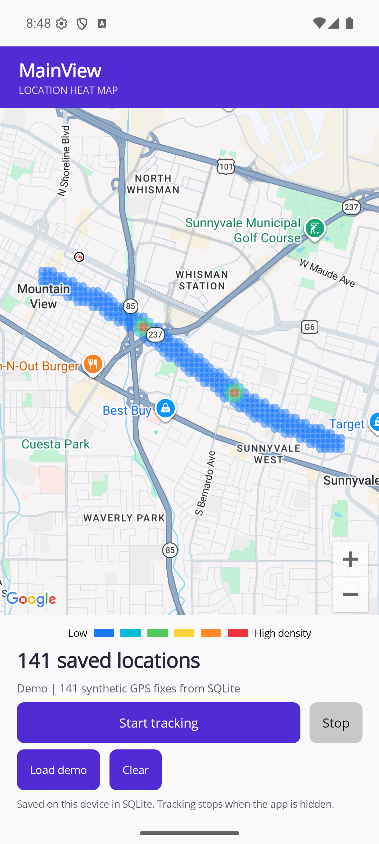
Figure 1. Native MAUI Maps control displaying Google Maps imagery and the heat overlay for 141 synthetic location fixes loaded from SQLite. The sample route demonstrates density rendering without recording a real journey.

Build and run
Open LocationHeatmap.sln in Visual Studio on Windows with the .NET MAUI workload and Android SDK 36 installed. Use a short project path, such as C:\Projects\LocationHeatmap, because Android resource compilation can exceed Windows path limits in deeply nested folders. The verified target is Android with .NET 10. An iOS target and location usage description are included for a Mac build; iOS was not tested.
dotnet workload install maui-android
dotnet build src/LocationHeatmap.App -f net10.0-android
dotnet run --project tests/LocationHeatmap.Checks
Configure an API key authorized for Maps SDK for Android before building. The shared AndroidManifest.xml retains a placeholder; the test build uses an ignored local manifest so its key is excluded from the report and source package. Restrict your own key to the application package and signing certificate. Enable device location services, tap Start tracking, and grant location access. Load demo displays a reproducible sample route on the same native map.

Validation
The Android build completed with zero warnings and zero errors and launched in a separate emulator. UI checks confirmed permission denial handling, recording an emulator GPS fix with 5-meter accuracy, stopping on backgrounding, reloading the saved fix after relaunch, and confirmed deletion of demo history. The demo path writes and reloads 141 samples through SQLite. Nine executable core checks cover persistence, validation, density, query limits, and deletion.
Both the sample route and recorded locations use the native MAUI Map extension. Location history is local and is not encrypted; this assignment does not implement background tracking or a cloud service.

Coding practices
The implementation uses descriptive PascalCase types and methods, camelCase parameters, nullable references, asynchronous database and GPS operations, cancellation, dependency separation, and comments explaining the density algorithm and platform behavior. SQL operations are parameterized through sqlite-net. Only C# is used, so the supplied JavaScript and Dart conventions do not apply.

References
Microsoft Learn MAUI Map and drawing elements
Microsoft Learn MAUI Geolocation
Microsoft Learn Common C sharp code conventions
sqlite net source and documentation

